TC01: Valid Login
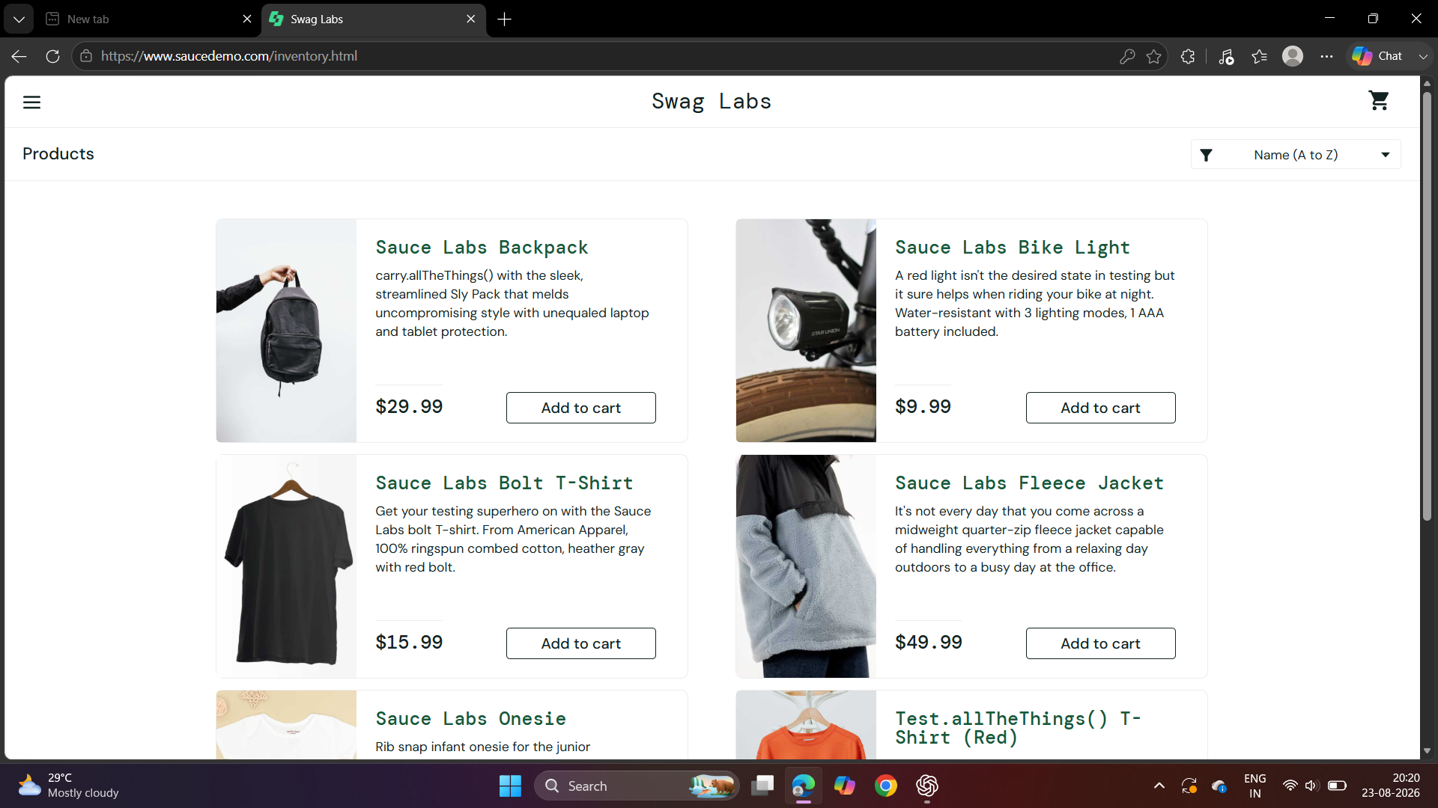

TC02: Invalid Login


TC03: Product Display

TC04: Add to Cart
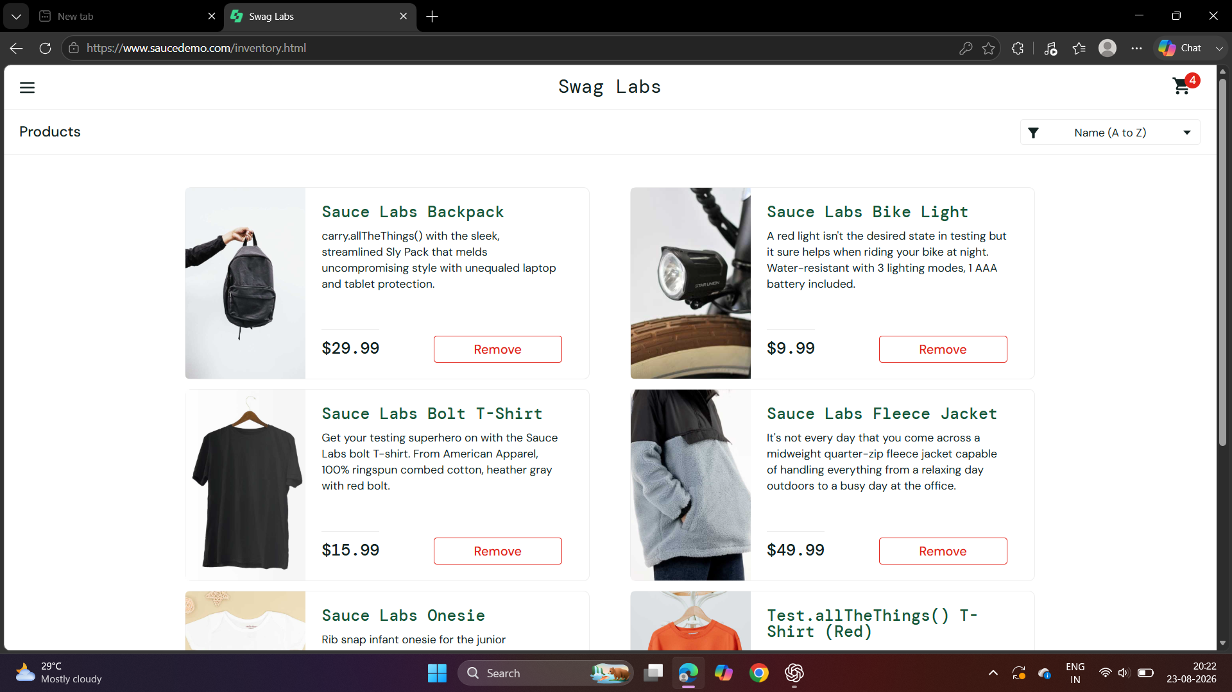

TC05: Remove from Cart TC05: Remove from Cart
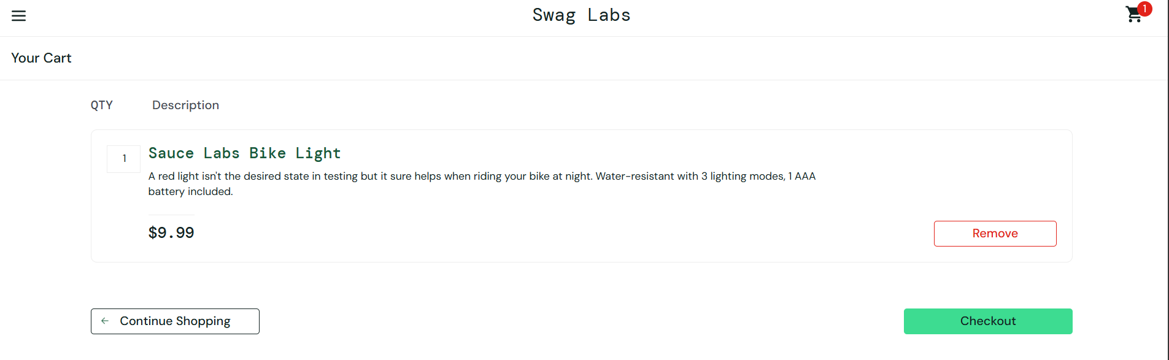
TC06: Cart 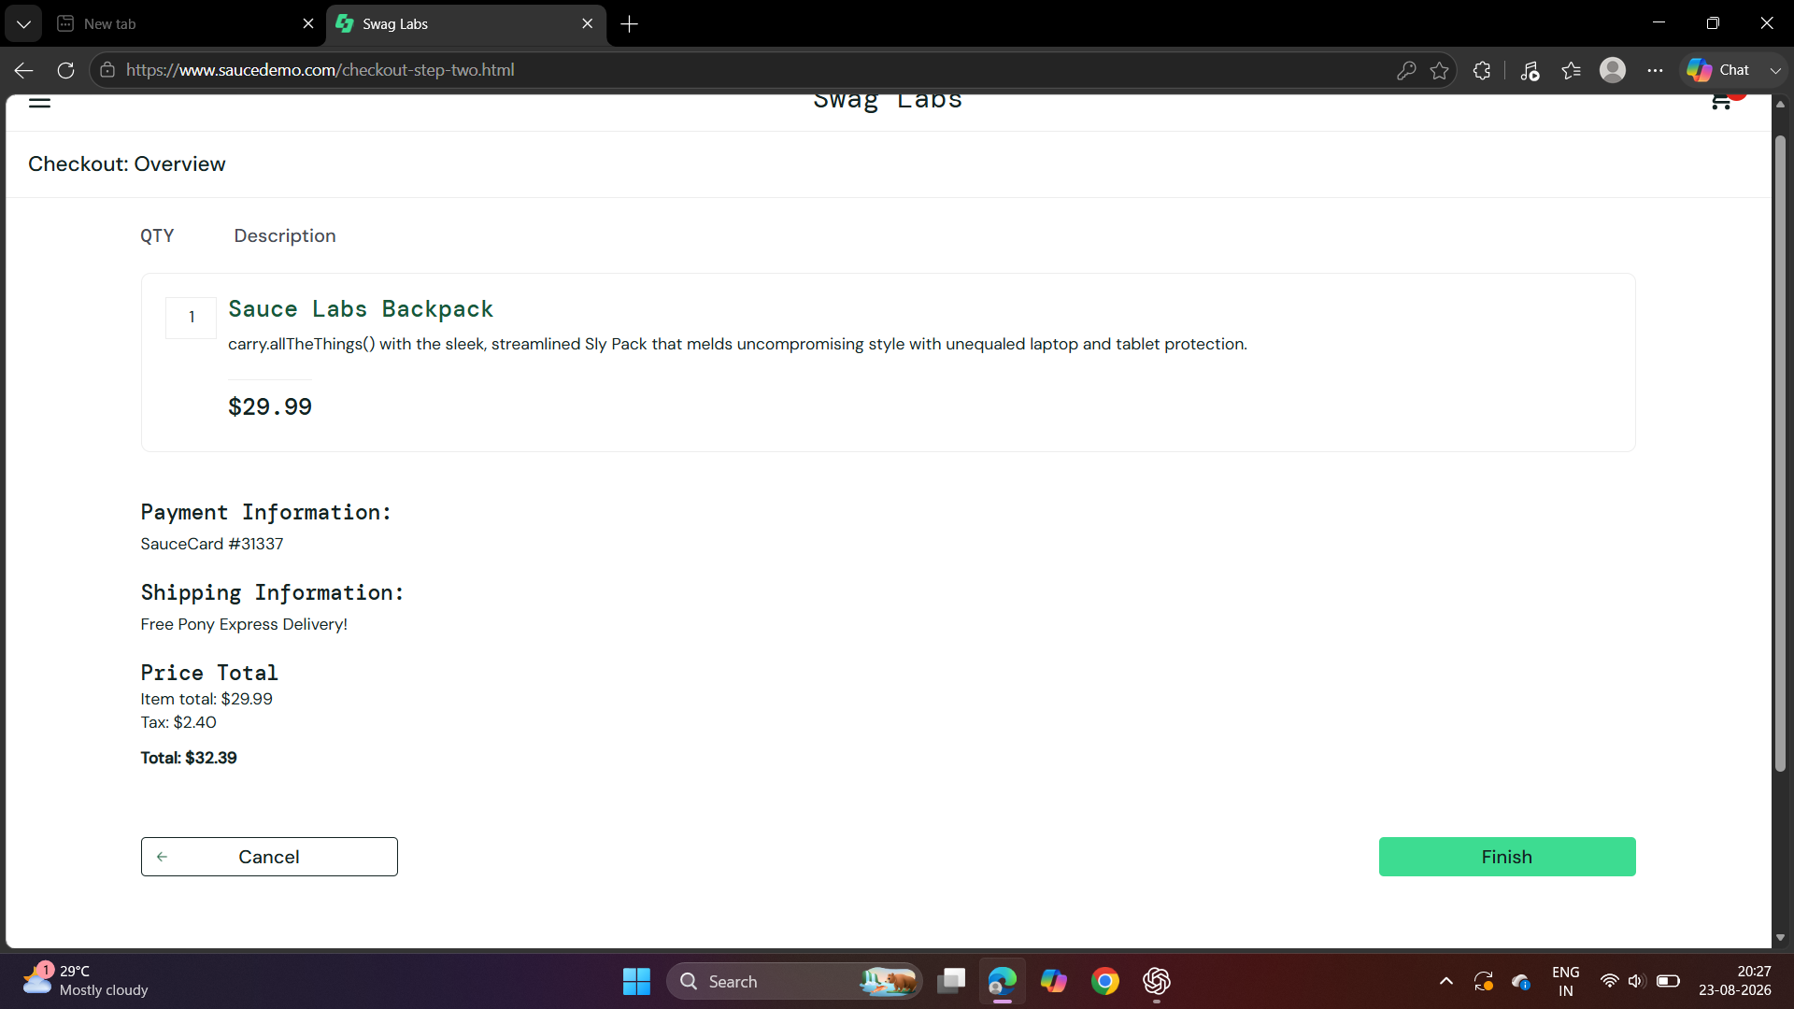
TC07: Checkout
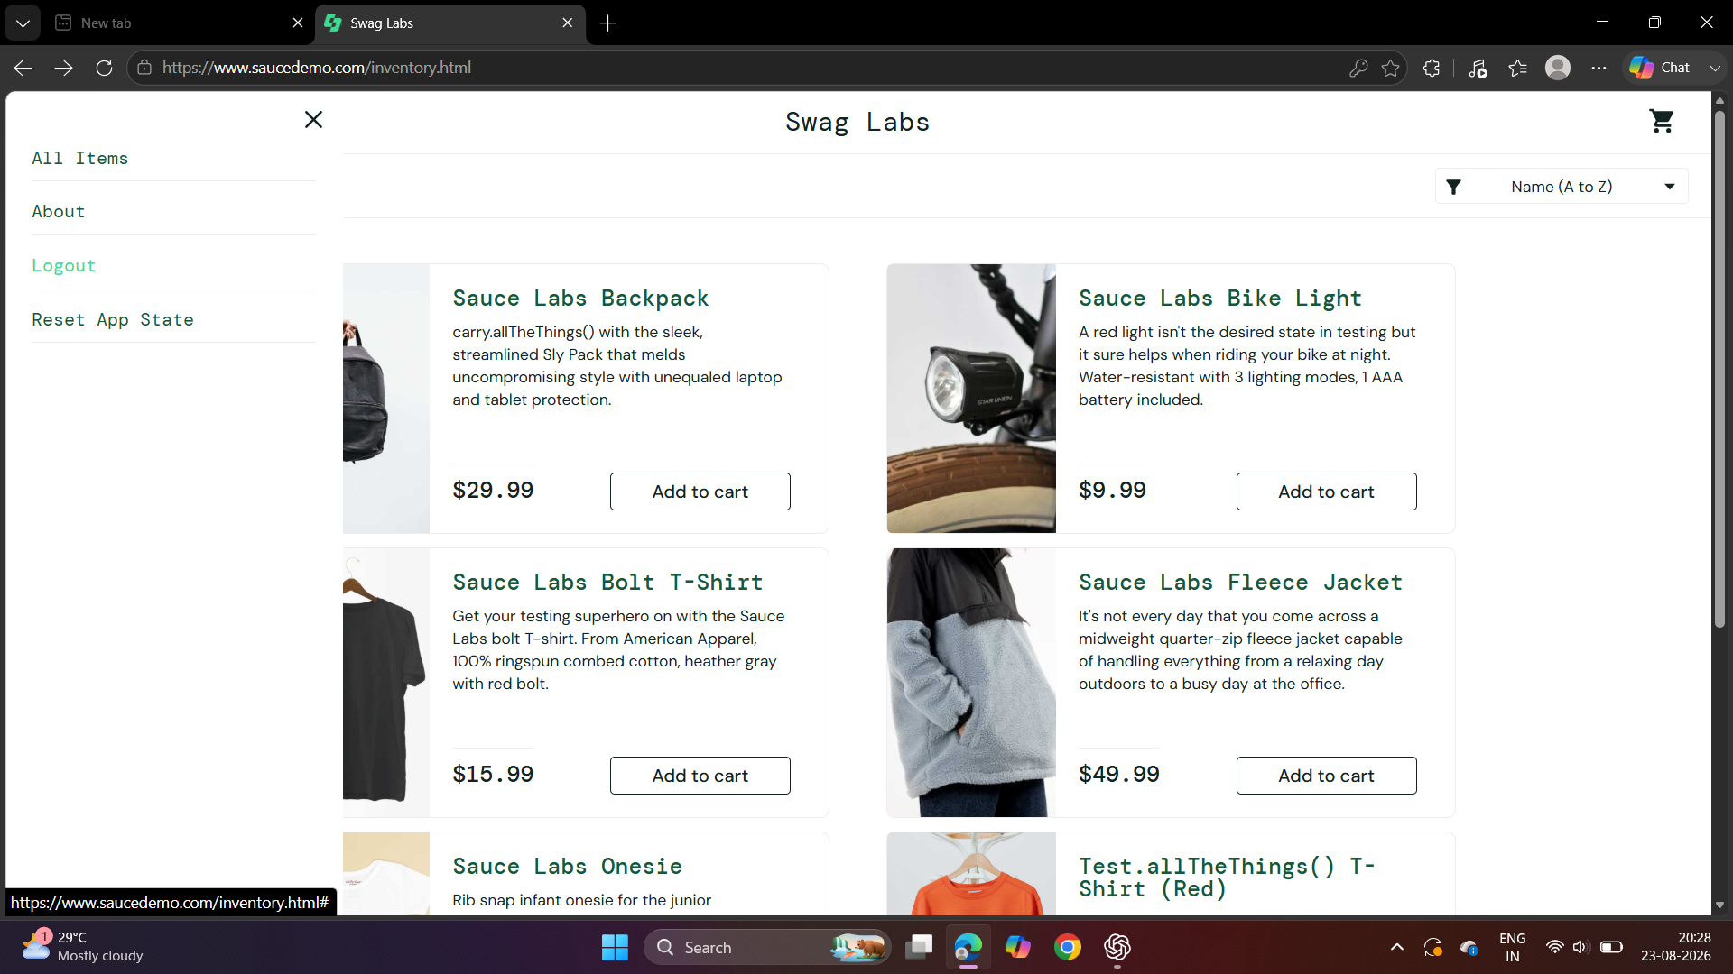

TC08: Logout
